

**KB Series pulsation dampeners**

**Use and maintenance Instruction**

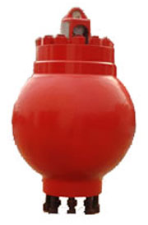

**Baoji mengtai petroleum machinery co.,ltd**

**Company Profile**

Baoji Mengtai Petroleum Machinery Co., Ltd. is a professional manufacturer and distributor of oil drilling and production equipment.

Our company's products have been sold to overseas markets and major domestic oil fields all the year round. We have good cooperative relations with our parters, such as CNPC, Sinopec and so on. Our company not only has its own production entity, but also sells other related petroleum materials and equipment all the time, The company now has a number of high-quality professional and technical personnel engaged in the development, production and manufacture of oil drilling and production equipment for many years, which can provide users with a full range of professional and satisfactory services.  
Our company strictly follows the production management system of ISO 9001:2000 and produces according to API 7K and ASY5138-92 standards, so that our products of oil drilling and production equipment have reliable quality assurance and international universal standards.

The company's production capacity has become large-scale and standardized. There are more than 50 professional machine tools and testing equipment to ensure the stability of product quality. The products are not only sold to Northwest Bureau of Sinopec, North China Bureau, Southwest Bureau, Qinghai Oilfield, Zhongyuan Oilfield, Changqing Oilfield and Sichuan Oilfield, but also to the United States, Canada, Kazakhstan, Egypt, Iran, United Arab Emirates, Venezuela and other countries.  
　　Baoji Mengtai Petroleum Machinery Co., Ltd. is willing to provide customers at domestic and abroad with high quality products and satisfactory services.

**一．**Main applications

This kind of product is produced by our company according to API-7K standard. It has the characteristics of high working pressure and long service life，It is widely used in drilling pumps of major oilfields to effectively reduce pressure fluctuation of discharge system so as to obtain stable fluid flow。

**二．**Technical Parameters

|  |  |  |  |  |
| --- | --- | --- | --- | --- |
| Model | Max.Working Pressure | Max. Volume | Max.Precharging Pressure | Connect with Pump |
| KB-25 | 35/52MPa | 25L | 4.5MPa | See Drawing |
| KB-45 | 35MPa | 45L | 4.5MPa | See Drawing |
| KB-75 | 35MP | 75L | 4.5MPa | See Drawing |
| KB-75H | 52MPa | 75L | 8.6 MPa | See Drawing |

Note: The products have passed to the <hydrostatic test> of 1.5 times working pressure according to Spec API 7K before they leave the factory.

**三．**Instructions for use

**\*** Installation with pump

Flanged connection

The flange at the bottom of the Pulsation Dampener is equipped with a sealing gasket ring，Clean washer ring, sealing groove and matching sealing groove thoroughly and coat with grease before empty installation. Put the gasket ring into the sealing groove of the elbow flange. The Pulsation Dampener is hoisted to the corresponding position of the drilling pump discharge elbow, and the stud is aligned with the stud mounting hole on the elbow flange. Install (take care not to touch the stud) tighten the nut，After tightening, its tightening moment of force is 1180N.m (the same value of bolt tightening moment of force each parts). When tightening the nut, the joint should be kept straight alignment, so the nut should be tightened cross-wise.

Hammer union connection type

If the bottom of the Pulsation Dampener is hammer union , thoroughly clean the union sealing surface, sealing groove and the matching sealing surface before installation, and coat it with a layer of grease, and put it into the sealing ring. The pulsation Dampener is hoisted to the corresponding part of the drilling pump discharge elbow, and the union nut is aligned with the male union on the elbow flange.

（During this process, Pay attention to prevent scratches on sealing rings. If necessary, the rings must be replaced immediately.），Hammer the nut on your hand until it is tightened in place。

**\*Charging**

Before starting the pump, pre-inflate the pulsation Dampener。

Warning: Use compressed nitrogen or compressed air only when inflating - not flammable and explosive gases such as oxygen or hydrogen.

The Charging air steps are as follows:

:

1. Remove the cover of the pulsation dampener pressure gauge and rotate the exhaust valve cover about 1/4~1/2 to discharge the pressure in the pressure gauge area. And Remove the exhaust valve cover and plug.
2. Connect the charging hose assembly to the nitrogen cylinder switch and the pulsation dampener exhaust valve; (When ordering, the charging hose assembly shall be matched at the request of the user)
3. Open pulsation dampener charging valve (Angle valve)；
4. Slowly open the nitrogen cylinder valve and adjust the gas flow rate into the pulsation dampener with the opening of the valve.；
5. Close the nitrogen cylinder valve when the pressure gauge of the pulsation dampener indicates the required pressure；
6. Close pulsation dampener charging valve (Angle valve)；
7. Remove hose, install exhaust valve, plug and valve cover, then open the charging valve to check whether the charging pressure value meets the requirements. If not, repeat the above 2-7 steps, and if so, the charging process is completed.

Note: In order to achieve the best results, the pre-charging pressure of pulsation dampener should not exceed 2/3 of the pump discharge pressure. The maximum charging pressure is 8.6 MPa (1247 psi) for KB-75H pulsation dampener and 4.5 MPa (652 psi) for other types of pulsation dampener.

At this point, the preparatory work before the installation and use of the pulsation dampener will be finished, and the pump can be ready to start at any time。

1. Operation: The drilling pump before operation must check whether the pressure in the pulsation dampener meets the requirements and whether the pulsation dampener charging valve (Angle valve) has been closed; during the operation of the drilling pump, the pulsation dampener charging valve (angle valve) must not be opened to prevent the pressure gauge of the pulsation dampener from being damaged by the high pressure in the pump.

**\*** Common failures and Solutions

Not breathable or leaking quickly：

**\*** Blockage of tracheal joint。Clean the connector and remove its internal debris;

**\*** The pulsation dampener bladder was damaged. The upper cover should be opened, the new pulsation dampener bladder should be replaced, and the inner cavity of the pulsation dampener should be cleaned when the bladder is replaced, and the surface condition of the inner cavity wall should be checked to avoid the insufficient strength of the shell caused by the erosion of drilling fluid.

**\*** Angle valve need to be repaired or replaced for gas leakage due to improper sealing。

Warning: When repairing and maintaining the pulsation dampener, the air pressure in the pulsation dampener must be zero, and the pressure of the pump must be zero. The pressure gauge can not be used to judge, because when the residual pressure is small, the pressure gauge can not be displayed, but this low pressure can also lead to accidents.

**四．Parts list（see attached）**

|  |  |  |  |  |  |  |  |  |  |  |  |  |  |  |  |  |  |  |  |  |  |  |  |  |  |  |  |  |  |  |  |  |  |  |  |  |  |  |  |  |  |  |  |  |  |  |  |  |  |  |  |  |  |  |  |  |  |  |  |  |  |  |  |  |  |  |  |  |  |  |  |  |  |  |  |  |  |  |  |  |  |  |  |  |  |  |  |  |  |  |
| --- | --- | --- | --- | --- | --- | --- | --- | --- | --- | --- | --- | --- | --- | --- | --- | --- | --- | --- | --- | --- | --- | --- | --- | --- | --- | --- | --- | --- | --- | --- | --- | --- | --- | --- | --- | --- | --- | --- | --- | --- | --- | --- | --- | --- | --- | --- | --- | --- | --- | --- | --- | --- | --- | --- | --- | --- | --- | --- | --- | --- | --- | --- | --- | --- | --- | --- | --- | --- | --- | --- | --- | --- | --- | --- | --- | --- | --- | --- | --- | --- | --- | --- | --- | --- | --- | --- | --- | --- | --- | --- |
| |  |  |  |  |  | | --- | --- | --- | --- | --- | | KB-25 Pulsation Dampener（Flanges）Part list | | | | | | Item | Part Number | Product Name | Qty | Remark | | 1 | LW-T58-5004 | Sealing Ring | 1 |  | | 2 | LW-AB25-04.01 | Case | 1 |  | | 3 | LW-AB25-04.02 | Bladder | 1 |  | | 4 | LW-AB25-04.03 | Cover | 1 |  | | 5 | LW-AB25-04.05.00 | Pressure Cover Assembly | 1 |  | | 6 | LW-AB25-04.06 | Joint | 1 | Borrowing | | 7 | LW-AB25-04.07 | Tee | 1 | Borrowing | | 8 | LW-AB25-04.08 | Angle Valve | 1 | Purchasing | | 9 | LW-AB25-04.09 | Pressure Gauge | 1 | Purchasing | | 10 | LW-AB25-04.10 | Washer | 1 | Borrowing | | 11 | LW-AB25-04.11 | Exhaust Valve | 1 | Purchasing | | 12 | LW-T50-6003 | Stud | 8 |  | | 13 | LW-AB25-04.12 | Nut1 | 8 |  | | 14 | LW-AB25-04.04 | Stud | 8 |  | | 15 | LW-AB25-04.13 | Nut | 8 |  |   Note: The connecting bolts of metric and british Pulsation Dampener are different, which should be noted when ordering。  **KB-25** Pulsation Dampener（Hammer Union Type）Part list | | | | | |
| Item | Part Number | Product Name | Qty | U.W | Remark |
| 1 | LW-AB25/52-04.01 | Case | 1 | 252 |  |
| 2 | LW-AB25-04.02 | Bladder | 1 |  |  |
| 3 | LW-AB25-04.03 | Cover | 1 |  |  |
| 4 | LW-AB25-04.05.00 | Pressure Cover Assembly | 1 | 4.45 |  |
| 5 | LW-AB25-04.06 | Joint 1/4(BF102.08.00) | 1 | 0.016 | Borrowing |
| 6 | LW-AB25-04.07 | Tee 1/4(BF102.06) | 1 | 0.2 | Borrowing |
| 7 | LW-AB25-04.08 | Angle Valve (BF102.08.00) | 1 | 0.5 | Purchasing |
| 8 | LW-AB25-04.09 | Pressure Gauge 0-25MPa Y-60 | 1 | 0.3 | Purchasing |
| 9 | LW-AB25-04.10 | Washer (T514-1001) | 1 | 0.002 | Borrowing |
| 10 | LW-AB25-04.11 | Exhaust Valve | 1 | 0.2 | Purchasing |
| 11 | LW-AB25/52-04.13 | Stud | 8 |  |  |
| 12 | LW-AB25/52-04.14 | Nut | 8 |  |  |
| 13 | D4-4-66 | O-Ring | 2 | 0.02 |  |
| 14 | 107.130.15 | Stud | 8 | 0.65 |  |
| 15 | 107.130.16 | Transition Joint | 1 | 46 |  |
| 16 | T58-5001 | Seal Ring | 1 | 0.2 |  |
| 17 | MT102.08 | Weld Flange | 1 |  |  |
| 18 |  | 1502 2"Union | 1 |  |  |
| 19 | LW-AB25/52-04.13 | Stud M33x2/M33x3x140 | 8 | 0.9 |  |
| 20 | LW-AB25/52-04.14 | Nut M33x3 | 8 | 0.36 | Purchasing |

Note: The connecting bolts of metric and british Pulsation Dampener are different, which should be noted when ordering

|  |  |  |  |  |
| --- | --- | --- | --- | --- |
| **KB-45** Pulsation Dampener Part list | | | | |
| Item | Part Number | Product Name | Qty | Remark |  |
| 1 | MT45520100.01 | Case | 1 |  |
| 2 | MT45520100.02 | Cover | 1 |  |
| 3 | MT45520100.03 | Pressure Cover Assembly | 1 |  |
| 4 | MT45520100.04 | Joint | 1 |  |
| 5 |  | Bladder | 1 | Borrowing |
| 6 | 753-4002 | Stud | 1 | Borrowing |
| 7 | 7508-6003 | Seal Gasket | 1 | Borrowing |
| 8 | L3802025225000620 | Double-scale pressure gauge 25MPa | 1 | Purchasing |
| 9 | 51260490003081 | Exhaust Vlave | 1 | Purchasing |
| 10 | T001-4201 | Tee | 1 | Borrowing |
| 11 | LW-AB25-04.11 | Angle Valve | 1 | Purchasing |

Note: The connecting bolts of metric and british Pulsation Dampener are different, which should be noted when ordering

|  |  |  |  |  |
| --- | --- | --- | --- | --- |
| **KB-75** Pulsation Dampener Part list | | | | |
| Item | Part Number | Product Name | Qty | Remark |
| 1 | T58-5001 | Seal Gasket R39 | 1 | Standard Parts |
| 2 | BF102.04.01 | Case | 1 |  |
| 3 | BF110.02 | Cover | 1 |  |
| 4 | BF102.06 | Tee 1/4 | 1 | Borrowing |
| 5 | BF102.07 | Joint 1/4 | 1 | Borrowing |
| 6 | BF102.08.00 | Pressure Cover Assembly | 1 |  |
| 7 | PJC1-L8 | Exhaust Valve | 1 | Purchasing |
| 8 | Y-60 | Pressure Gauge 0-25MPa | 1 | Purchasing |
| 9 | JZR3-L8 | Angle Valve | 1 | Purchasing |
| 10 | BF102B.03.00 | Bladder | 1 | Purchasing |
| 11 | T514-1001 | Washer | 1 | Standard Parts |
| 12 | T50-6002 | Stud 1 1/2-12UNF/1 1/2-8UNC×5 1/8 | 12 | Standard Parts |
| 13 | T51-2001 | Nut | 12 | Standard Parts |
| 14 | T50-6003 | Stud | 8 | Standard Parts |
| 15 | T51-2002 | Nut | 8 | Standard Parts |

Note: The connecting bolts of metric and british Pulsation Dampener are different, which should be noted when ordering

**KB-75H** Pulsation Dampener Part list

|  |  |  |  |  |
| --- | --- | --- | --- | --- |
| Item | Part Number | Product Name | Qty | Remark |
| 1 | AK755201-0102 | Spacer flange | 1 |  |
| 2 | AK755201-0103 | Stud | 8 |  |
| 3 | AK755201-0104 | Stud | 8 |  |
| 4 | T507-2017 | Nut | 16 |  |
| 5 | AH220201-0520 | Fluid Cylinder Seal ring | 16 |  |
| 6 | T507-2001 | Nut | 1 |  |
| 7 |  | O-Ring | 8 |  |
| 8 | AK755201-0101 | Case | 1 |  |
| 9 | AK755201-02 | Cover | 1 |  |
| 10 | AK755201-0300 | Pressure Gauge Cover Assembly | 1 |  |
| 11 | AK755201-0400B1 | Bladder Assembly | 1 |  |
| 12 | T508-6003 | Gasket | 1 |  |
| 13 | T511-2001 | Tee | 1 |  |
| 14 | PJC1-L8 | Exhaust Valve | 1 |  |
| 15 | Y-60 | Double-scale | 1 |  |
| 16 |  | Angle Valve | 1 |  |
| 17 | AK455201-04 | Joint | 1 |  |
| 18 |  | Loctite | As needed |  |

**五．Structure Composition（See Drawing）**

**KB-25 Pulsation Dampener(Flange Type) Structure Diagram**

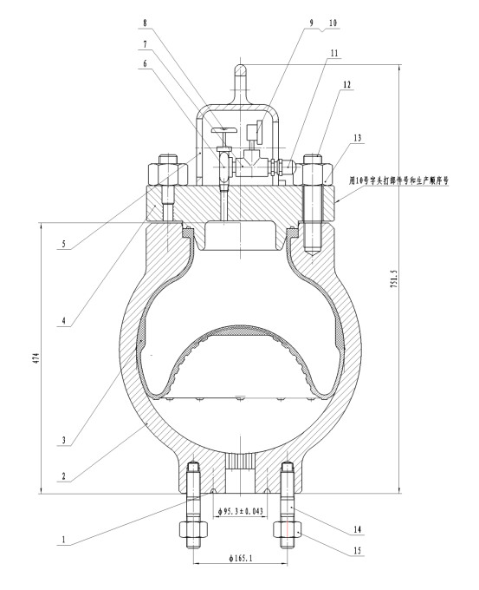

**KB-25 Pulsation Dampener(Hammer Union Type) Structure Diagram**

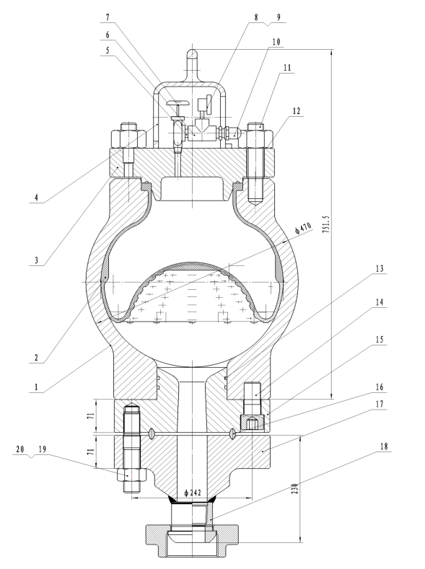

**KB-45 Pulsation Dampener Structure Diagram**

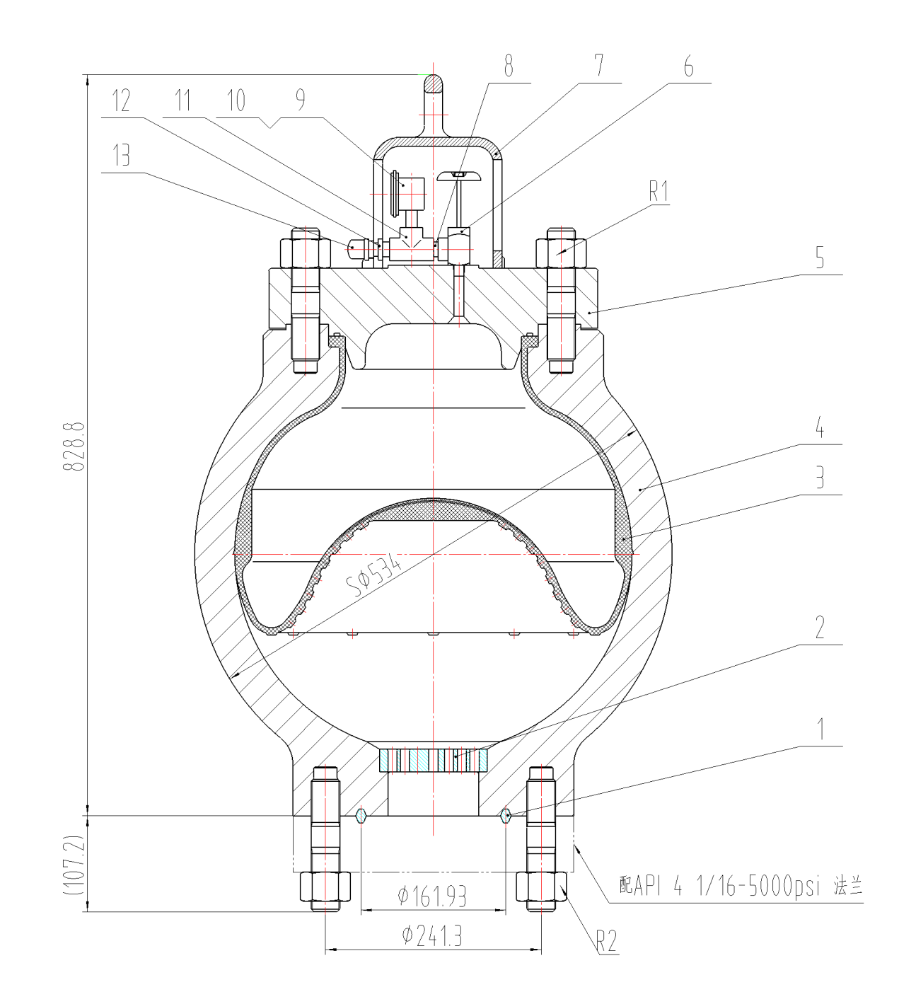

**KB-75 Pulsation Dampener Structure Diagram**

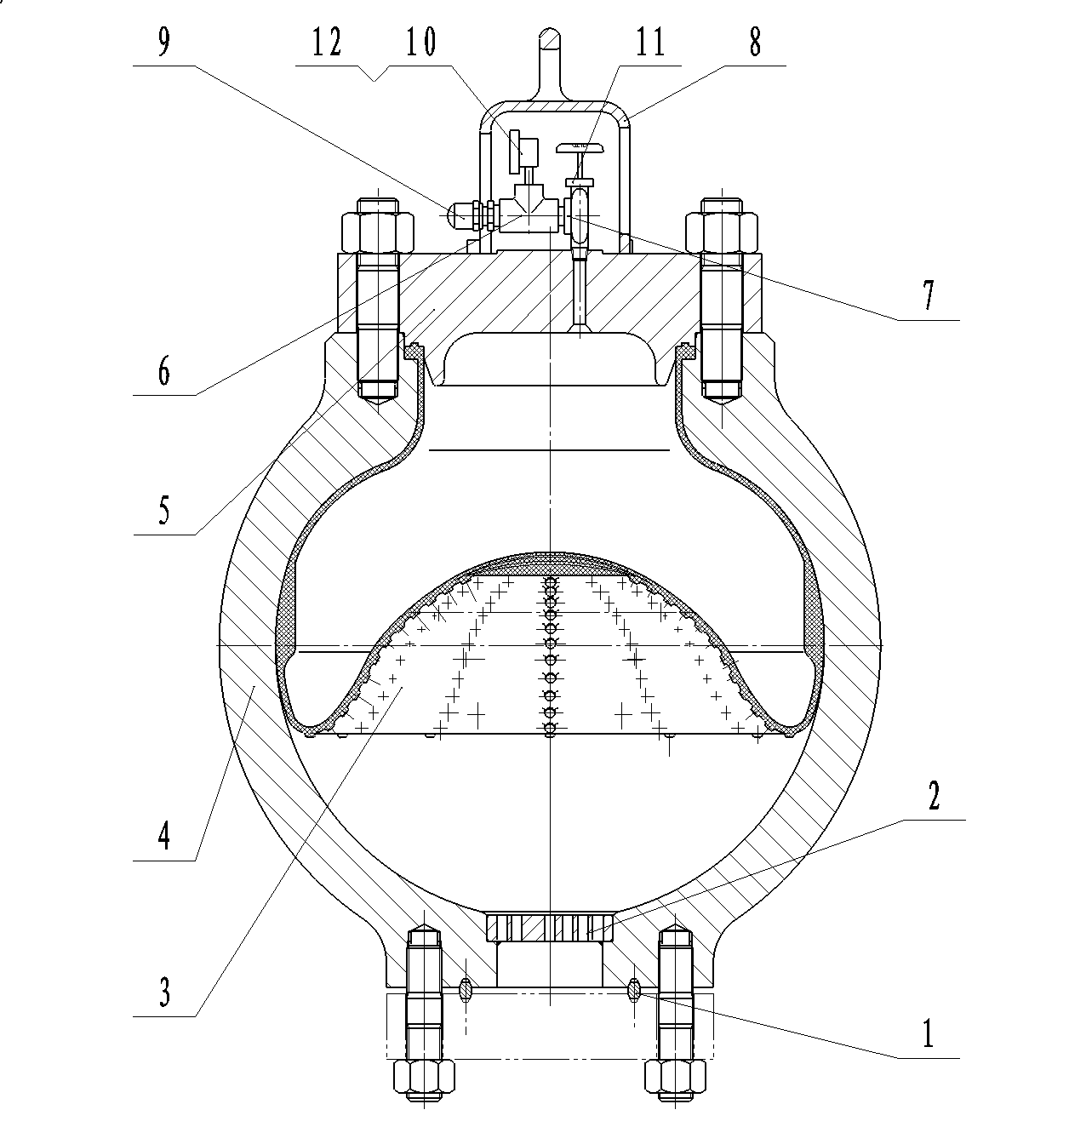

**KB-75H Pulsation Dampener Structure Diagram**

